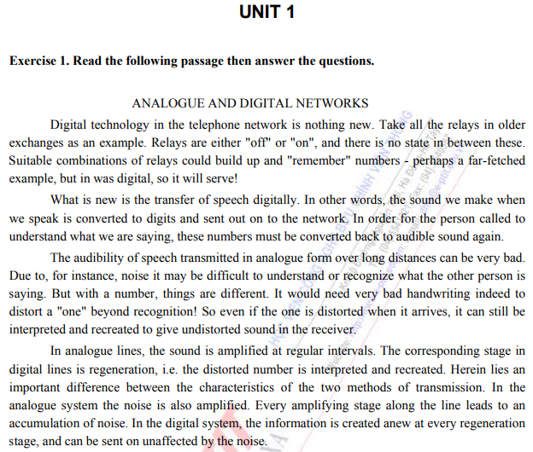

1. **Write True (T) or False (F) for each sentence. If false, say what is true.**
2. The telephone network has used digital technology for a long time. $T$
3. It has been possible to transfer speech digitally for a long time. $F$
4. Speech cannot be converted into digits. $F$
5. Speech transmitted in analogue form is never very clear. $F$
6. Sometimes noise on the line makes it impossible to hear what a $T$

person is saying on the telephone.

1. Digital transmission is never affected by noise. $F$
2. Even if affected by noise, digits can still be interpreted easily. $T$
3. Only the sound of speech, not noise, is amplified in analogue lines. $F$
4. Digital signals are also amplified at regular intervals. $T$
5. Digital transmission is superior to analogue. $T$
6. **Now complete these sentences with a word starting with RE.**

Note: RE means again or back.

Example: *recreate* means to create again; *regenerate* means to generate again.

1. It is not difficult to $recreate (tái tạo)$ digital signals.

* Không khó để tái tạo lại tín hiệu kỹ thuật số.

1. We can $regenerate (tái sinh)$ the signals at regular intervals in digital lines.

* Chúng ta có thể tạo lại các tín hiệu theo khoảng thời gian đều đặn trong đường truyền kỹ thuật số.

1. The telephone receiver can $reconvert (chuyển đổi lại)$ an electrical signal to audible sound.

* Bộ thu điện thoại có thể chuyển đổi lại tín hiệu điện thành âm thanh nghe được.

1. Every year I $reorganize (tái tổ chức)$ the furniture in my room.

* Hằng năm tôi đều sắp xếp lại đồ đạt trong phòng mình.

1. I failed the test, so now my teachers will $reteach (học lại)$ me.

* Tôi đã trượt bài kiểm tra, vì vậy bây giờ giáo viên của tôi sẽ dạy lại tôi.

1. **Find the opposites of these words.**

distorted (biến dạng) 🡪 **undistorted** (không bị biến dạng)

important (quan trọng) 🡪 **unimportant** (không quan trọng)

affected (bị ảnh hưởng) 🡪 **unaffected** (không bị ảnh hưởng)

suitable (thích hợp) 🡪 **unsuitable** (không thích hợp)

audible (nghe được) 🡪 **inaudible** (không nghe được)

possible (có thể) 🡪 **impossible** (không thể, không khả thi )

Now complete the sentences with a word starting with **un**, **in** or **im**.

1. The sound is **unaffected** by noise in digital lines.

* Âm thanh không bị nhiễu ở các dòng kỹ thuật số.

1. Optical fibre systems are **unimportant** where there is not much traffic.

* Hệ thống cáp quang không quan trọng ở những nơi không có nhiều lưu lượng.

1. Transmission by optical fibre cables is **unaffected** by bad weather.

* Đường truyền bằng cáp quang không bị ảnh hưởng bởi thời tiết xấu.

1. Sometimes it is **impossible** to understand what a person is saying.

* Đôi khi không thể hiểu được một người đang nói gì.

1. It's an **unsuitable** day today. I lost my money.

* Hôm nay là một ngày không thích hợp. Tôi đã mất tiền.

1. You must speak louder - your voice is **inaudible**.

* Bạn phải nói to hơn - giọng của bạn không nghe được.

1. Don't worry about your clothes - it's **unimportant** what you look like.

* Đừng lo lắng về quần áo của bạn - bạn trông như thế nào không quan trọng.

1. I wish I could find an **impossible** present for my husband.

* Ước gì tôi có thể tìm được một món quà bất khả thi cho chồng.

1. **Look through the reading passage again and find the nouns which go with these verbs.**

Example: to arrive (verb) 🡪 the arrival (noun),

Inform 🡪 **Information** interpret 🡪 **interpretation**

Distort 🡪 **Distortion** recreate 🡪 **recreation**

Transmit 🡪 **Transmission** amplify 🡪 **amplification**

recognise 🡪 **recognization** accumulate 🡪 **accumulation**

regenerate 🡪 **regeneration** combine 🡪 **combination**

communicate 🡪 **communication**

**Exercise 2. Complete the sentences, using suggested words.**

|  |  |
| --- | --- |
| 1. **Transmission** in the telecommunications networks of today is, more and more, digital in nature, and the transmission medium of choice is fiber. 2. “Digital”, however, does no more than imply a string of 1s and Os **racing** through the network. 3. But how are these 1s and Os to be **arranged** ? 4. At what speed **are** they to travel? 5. What route should they **take** ? 6. Answers to questions such as these have taken many forms and have made for the most **complicated** aspect of the telecommunications business. 7. There has never been a **scarcity** of coding schemes in the industry. 8. Starting with Morse code, going to the Baudot code, then the ASCII code, we have seen each providing for **better** transmission and higher quality. | transmit  race  arrange  be  take  complicate  scare  good |

**Exercise 3. A. Fill in the blanks with suitable noun form of the given words.**

EXAMPLES OF EXTERNAL NATURAL / MANMADE FORCES

• Natural Environ-mental Forces

* Temperature:

Due to freezing: - Increased ground **resistance** (1. resist)

- Loose poles

- Compressive collapse of cable inside duct

Due to changing temperature:

- Cracks, **expansion** (2. expand)/ contraction

* Wind (mist, etc.): - Collapse, vibration cracks, **disconnection** (3. disconnect), corrosion

* Rain, water (ground seapage, etc.): - Flooding, corrosion

* Snow: - Disconnection and **destruction** (4. destroy) by accumulated snow

- Insufficient **height** (5. high) for cable due to fallen snow - Corrosion, insulation **failure** (6. fail)

* Humidity: - Cable sheath damage, corrosion of cable conductor

* Sand storms: - Destruction

* Earthquake: - Disconnection, collapse due to land subsidence

* Geology/ geography:

+ Sun light: - **discoloration** (7. discolor), **deterioration** 8. deteriorate)

+ Mice, birds, bugs...: - **damage** (9. damage)

• Manmade Environmental Forces:

* Electric power line: - Induction

* DC railway: - Electrical corrosion

* AC railway: - **induction** (10. induct)

* Distribution line: - Induction

* Smoke from plants, etc. : - Corrosion

* Cars (vibration, smoke): - Cracks, breaks, corrosion

* General work: - Cuts, destruction

**Exercise 4. Read the following text carefully.**

CLASSIFICATION OF OUTSIDE PLANTS

1. **Classification by application.**

Line networks are roughly classified by application into subscriber lines that connect telephone offices to subscribers and lines that connect telephone offices.

Subscriber lines are divided into distributed cable networks that efficiently store plandistributed subscribers, and feeder cable networks that concentrate distributed cable networks and connect them to telephone offices using multiple pair cable.

Interoffice lines are divided into fairly short junction lines that connect telephone offices within the subscribers' area, and medium- /long-distance toll lines that connect telephone offices outside the subscribers' area. These classifications are shown below.

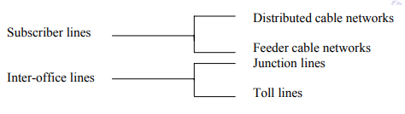

1. **Classification by set-up site.**

Where line networks are set up can roughly be classified as indoor and outdoor. Outdoor set-up sites are divided into overhead, underground and submarine sites, while indoor set-up sites are either telephone offices or subscribers’ homes. This is how line networks are classified according to set-up site.

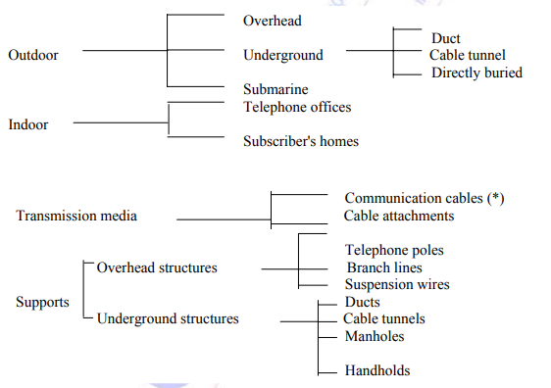

1. Classification of components.

Outside plant components are roughly classified into transmission media and the supports.

Transmission media are divided into communication cables and cable attachments, such as junction boxes, etc., while supports are divided into overhead structure and underground structures. The Figure above shows these classifications.

* Types of communication cable by its structure.

Communication cable can be classified by its structure into balanced pair cable and coaxial cable, both of which use metal conductors, and optical fiber cable, which uses glass fiber, and has recently received much attention. The classification of communication cable by its structure is shown below.

